**Truth, Beauty, and Goodness: Fundamentals of Catholicism**

**SYLLABUS**

(by Fr. Robert Altier)

Oct 6: The Oneness of God / The Attributes of God

Oct. 13: One God in Three Persons / The Three Persons of the Holy Trinity

Oct. 20: Creation of the World / Creation of the Human Person

Oct 27: Creation of the Angels / Human Nature & Original Sin

Nov. 3: Who is Jesus Christ? / The Incarnation of Jesus Christ

Nov. 10: The Humanity of Jesus / Jesus the Christ

Nov. 17: Mary: The Immaculate Conception / Mary: The Divine Maternity

Nov. 24: Mary: Mediatrix and Redemptrix of all Graces / Mary: Intercession of Mary

Dec. 1: Ecclesiology / The Papacy

**Dec. 8: (NO CLASS) (Mass of the Immaculate Conception at the church: 7:30 pm)**

Dec 15: The Infallibility of the Church / The Four Marks of the Church

Dec. 22: Divine Revelation / Sacred Scripture

**++++Christmas Break++++**

Jan 5: Inspiration of Scripture / The Canon of Scripture

Jan 12: Grace / Grace and Final Perseverance

Jan 19: Our Free Will and Salvation / Sanctifying Grace and Merit

Jan 26: The Sacramental Theology of the Church (Part 1 and Part 2)

**Feb. 2: (NO CLASS): Mass of the Feast of the Purification, 7:30 pm Mass, at the church**

Feb 9: The Sacramental Theology of the Church (Part 3) / Baptism and Confirmation

Feb. 16: The Eucharist, Part 1 / The Eucharist, Part 2

Feb. 23: The Eucharist Part 3 / The Eucharist, Part 4

March 1: The Eucharist Part 5 / The Mass

March 8: Confession Part 1 / Confession Part 2

March 15: Confession Part 3 / Confession Part 4

March 22: Anointing of the Sick / Holy Matrimony Part 1

**Easter: Sunday March 27**

March 29: Holy Matrimony Part 2 / Holy Matrimony Part 3

April 5: Holy Orders Part 1 / Holy Orders Part 2

April 12: Moral Theology Part 1 / Moral Theology Part 2

April 19: The Norms of Moral Theology / The Conscience

April 26: The Dignity of the Human Person, Part 1 / Dignity of the Human Person Part 2

May 3: Eschatology, Part 1 / Eschatology Part 2

May 10: Eschatology Part 3 / Eschatology Part 4

May 17: Prayer Part 1 / Prayer Part 2

**Fr. Robert Altier**

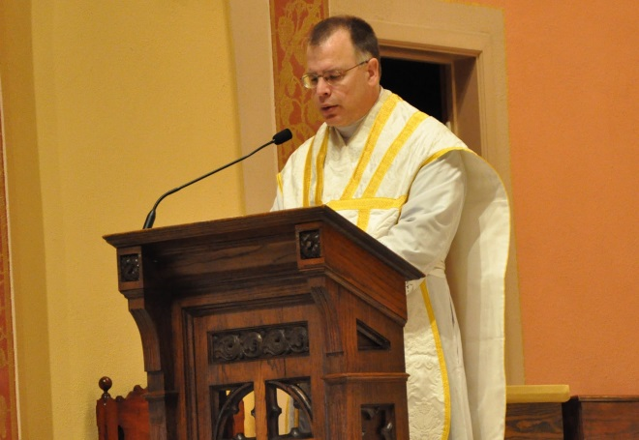We will be presenting a series of recordings by Father Robert Altier; in addition, Fr. Deprey will review the topic presented and provide supplementary material. Each video segment (2 per class) is about 25 min in length and presents the basic teachings of the Roman Catholic Church. We will end the class sometime before 9:00 pm.

Father Robert Altier is a Roman Catholic priest in the archdiocese of Saint Paul-Minneapolis, MN, USA. Ordained in 1989, he has served as assistant pastor at the Church of Saint Agnes in Saint Paul, Minnesota. He currently says the weekly Traditional Latin Mass at 8 am at St. Joseph Parish in Miesville, MN.. Father is a member of the Secular Order of Discalced Carmelites and author of *An Examination of Conscience: A Preparation for the Sacrament of Confession* printed by Loyola Press. He is also spiritual director and a board member of *Catholic Parents OnLine*, a lay initiative which seeks to keep parents of school aged children informed regarding issues pertinent to parents and education.