**Truth, Beauty, and Goodness: Fundamentals of Catholicism**

**Revised SYLLABUS**

(by Fr. Robert Altier)

Jan 12: Inspiration of Scripture / The Canon of Scripture

Jan 19: Grace / Grace and Final Perseverance

Jan 26: Our Free Will and Salvation / Sanctifying Grace and Merit

**Feb. 2: (NO CLASS): Mass of the Feast of the Purification, 7:30 pm Mass, at the church**

Feb. 9 : The Sacramental Theology of the Church (Part 1 and Part 2)

Feb 16: The Sacramental Theology of the Church (Part 3) / Baptism and Confirmation

Feb. 23: The Eucharist, Part 1 / The Eucharist, Part 2

March 1: The Eucharist Part 3 / The Eucharist, Part 4

March 8: The Eucharist Part 5 / The Mass

March 15: Confession Part 1 / Confession Part 2

March 22: Confession Part 3 / Confession Part 4

**Easter: Sunday March 27**

March 29: Anointing of the Sick / Holy Matrimony Part 1

April 5: Holy Matrimony Part 2 / Holy Matrimony Part 3

April 12: Holy Orders Part 1 / Holy Orders Part 2

April 19: Moral Theology Part 1 / Moral Theology Part 2

April 26: The Norms of Moral Theology / The Conscience

May 3: The Dignity of the Human Person, Part 1 / Dignity of the Human Person Part 2

May 10: Eschatology, Part 1 / Eschatology Part 2

May 17: Eschatology Part 3 / Eschatology Part 4

May 24: Prayer Part 1 / Prayer Part 2

**Fr. Robert Altier**

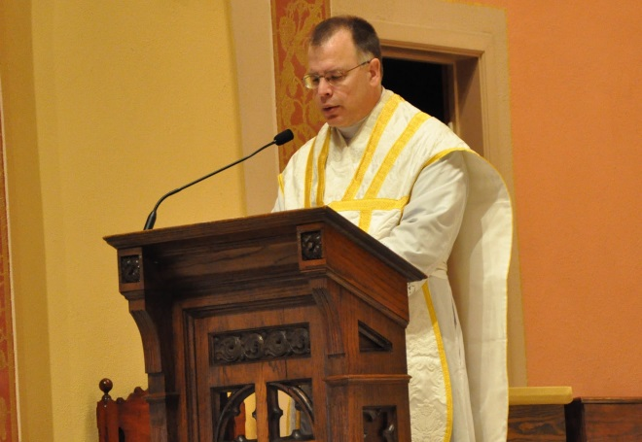We will be presenting a series of recordings by Father Robert Altier; in addition, Fr. Deprey will review the topic presented and provide supplementary material. Each video segment (2 per class) is about 25 min in length and presents the basic teachings of the Roman Catholic Church. We will end the class sometime before 9:00 pm.

Father Robert Altier is a Roman Catholic priest in the archdiocese of Saint Paul-Minneapolis, MN, USA. Ordained in 1989, he has served as assistant pastor at the Church of Saint Agnes in Saint Paul, Minnesota. He currently says the weekly Traditional Latin Mass at 8 am at St. Joseph Parish in Miesville, MN.. Father is a member of the Secular Order of Discalced Carmelites and author of *An Examination of Conscience: A Preparation for the Sacrament of Confession* printed by Loyola Press. He is also spiritual director and a board member of *Catholic Parents OnLine*, a lay initiative which seeks to keep parents of school aged children informed regarding issues pertinent to parents and education.